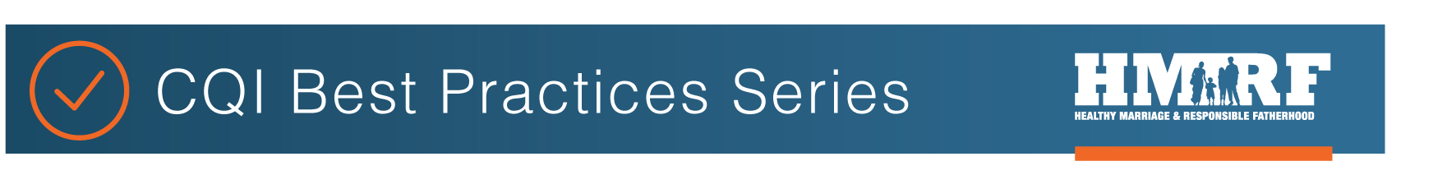
OPRE report #2022-192
GRANTEE IMPLEMENTATION TEAM SAMPLE MEETING AGENDA [FOR USE BY HMRF GRANTEES]
Implementation Team Agenda Sample Template
A core function of implementation teams is to routinely review, analyze, and synthesize data. The draft agenda template below provides a framework for how implementation teams can review and analyze data to inform decision-making using the W³ (What, So What, Now What?) strategy. At each meeting, the team should review relevant data and revisit previous improvement actions and goals.

Date and Time:
Phone Meeting or Meeting Location:

Attendees:
Regrets:

Facilitator: Time Keeper:
Note Taker:

Objectives for Meeting:
- Use the W³ strategy to identify and prioritize implementation strengths and challenges from the data and to identify patterns and trends in the data;
- Discuss the data patterns and opportunities for improvement, co-create concrete strategies and responsibilities for improvement, and identify next steps to improve implementation.

TIME | TASK/ACTIVITY (WHAT & HOW) | POTENTIAL RESOURCES
 | What:  - What is the particular implementation issue we are reviewing today?  - What stands out about it?  - Are there patterns in the data?  - Are there patterns month-to- month?  - Are we noticing any trends? | Monthly Tracking Tool  nFORM Data  Additional Information
 | So What:  - Why is this important?  - What conclusions can we make?  - What progress/changes have we seen since our last meeting? | Team Discussion
 | Now What:  - What actions make sense based on these data?  - What implementation supports might need to be strengthened?  - What supports do staff need?  - How will we determine that progress is being made?  - How will we know if we are successful in supporting change? | Implementation Drivers Overview  (see: https://nirn.fpg.unc.edu/module-1/implementation-drivers)

IDENTIFIED FOLLOW-UP ACTIONS AND PLAN

Action Needed | Resources | Person Responsible | Timeframe

This resource was written by Sarah Avellar (Mathematica) and Liz Pollock (Office of Planning, Research, and Evaluation (OPRE)) based on materials from the University of North Carolina’s Frank Porter Graham Child Development Institute - National Implementation Research Network in collaboration with the Administration for Children and Families’ Office of Family Assistance (OFA) and OPRE (contract #HHSP2332009564WC/ HHSP23337050T). OPRE Project Officers: Katie Pahigiannis and Pooja Gupta Curtin. Mathematica Project Director: Sarah Avellar.
Suggested citation: Avellar, S. and L. Pollock (2020). Grantee Implementation Team Sample Meeting Agenda (OPRE Report 2022-192). Washington, DC: Office of Planning, Research and Evaluation, Administration for Children and Families, U.S. Department of Health and Human Services.

What, So What, Now What? W³. (n.d.). Retrieved from http://www.liberatingstructures.com/9-what-so-what-now-what-w/

