

CONTINUOUS QUALITY IMPROVEMENT CYCLE WORKSHEET

Instructions
This optional resource can be used to guide planning for continuous quality improvement (CQI) cycles and discussions about progress with your grant’s Family Assistance Program Specialist (FPS) in the Office of Family Assistance (OFA). OFA guidance is to discuss your CQI efforts with your FPS and in your annual Performance Progress Report (PPR), and to update your data capacity and CQI plan if you change anything about your CQI team or broader CQI approach.

Your team should prepare a new worksheet for each CQI cycle. The timing of each cycle depends on the challenge your team is addressing, and your strategy for improvement. This worksheet, which can be found on the HMRF Grant Resource site, is a fillable Word document to facilitate collaboration among CQI team members.
The worksheet is divided into sections that correspond to steps in the CQI cycle (Figure 1). Each section includes links to key resources relevant to that step in the CQI cycle. You can also find many other resources on the HMRF Grant Resource site, including tip sheets, tools, and office hours materials, that can help your team enhance its CQI approach.

Figure 1. CQI cycle
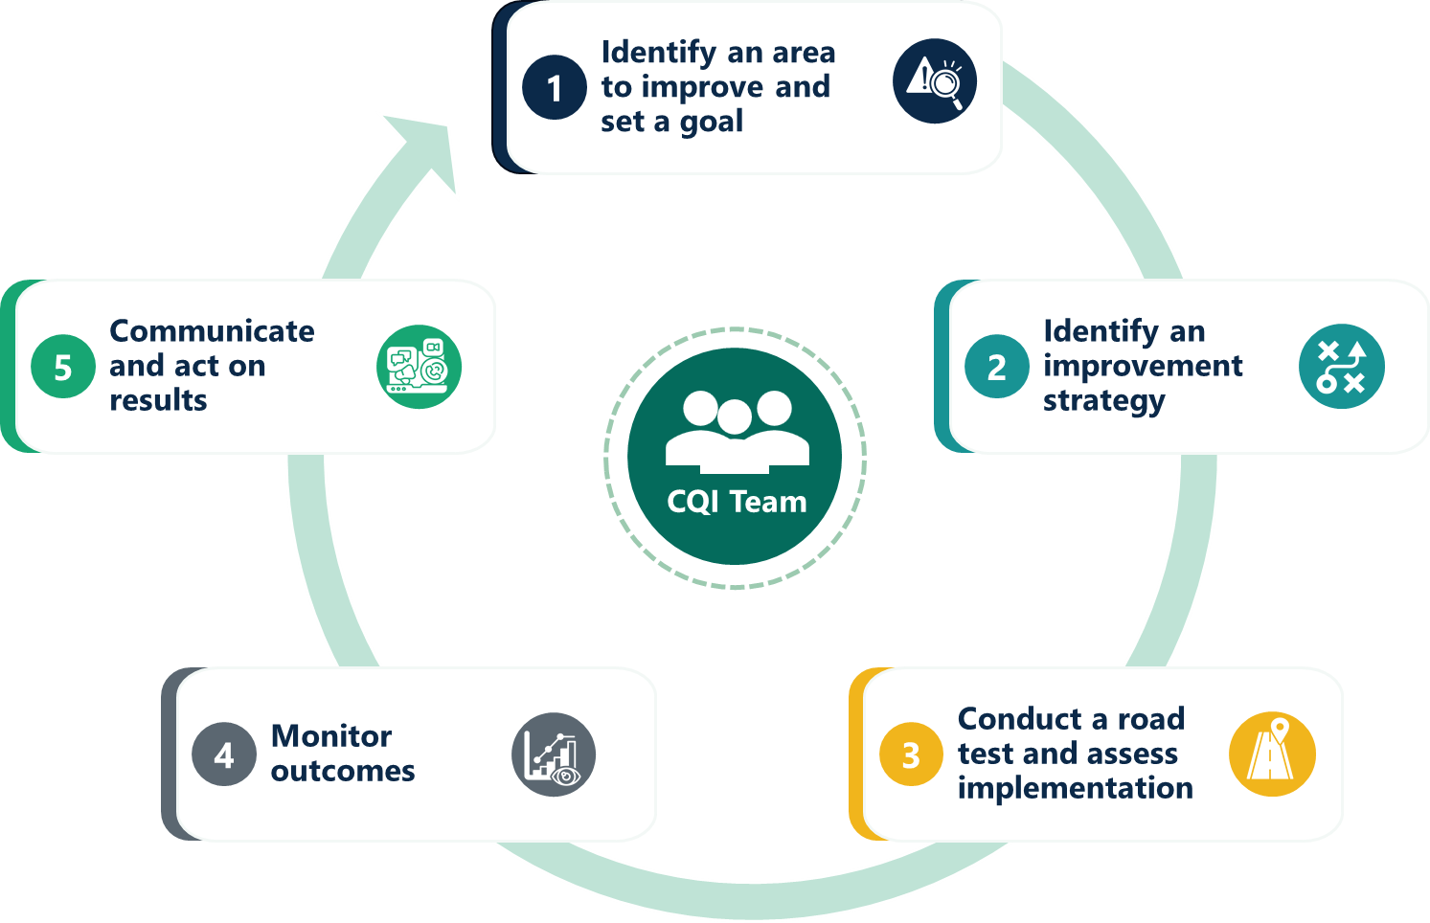

Overview of this CQI cycle
Grant recipient name: Click or tap here to enter text.
CQI team lead: Click or tap here to enter text.
Start date of CQI cycle: Click or tap here to enter text.
Focus of CQI cycle: Click or tap here to enter text.

Team for this CQI cycle
Each CQI cycle requires a team effort to plan, carry out, and monitor all activities that are needed to address a programmatic challenge.
- The core CQI team members who lead each cycle: CQI team lead (identified in the Overview above), data manager, evaluator, project director, and project manager (as applicable).
- Improvement advisors who can provide firsthand knowledge and perspectives on the challenge you are trying to address with this CQI cycle. These advisors can offer their understanding of why the challenge is occurring and help brainstorm new strategies to help resolve the challenge.
- Supervisors who oversee the staff who are implementing the new strategies.
The core CQI team members should be involved in every CQI cycle. Be sure to review and update Section D1 (CQI team structure) in your data capacity and CQI plan if your core CQI team membership changes. Improvement advisors and supervisors may remain consistent for every CQI cycle or may change depending on the topic.
Who are the core CQI team members, improvement advisors, and training supervisors for this CQI cycle?
CQI team role | Names of specific staff for this cycle
Core CQI team members
Improvement advisors
Supervisors

Steps for this CQI cycle

Step 1. Identify an area to improve and set a goal
What is the specific problem or issue you are trying to solve? Drill down on nFORM and other program data and talk to relevant collaborators, like staff and participants, to learn more about the problem. Then, write a comprehensive problem statement to be clear about what challenge the team is aiming to resolve, where the challenge is occurring in your program, and the root cause(s) of the challenge.
EXAMPLE: The New Families program has fallen below internal enrollment targets for the past three months. Wanting to better understand the issue, the program examines the average time between the first recruitment touchpoint and enrollment for new clients. The team learns that if two or more weeks pass between recruitment and enrollment, people are less likely to enroll. They now have a more refined understanding of the problem. They are ready to draft their comprehensive problem statement describing the high-level challenge (low enrollment) and the underlying root cause of the challenge (clients are disengaging between recruitment and enrollment).

Write your problem statement: Click or tap here to enter text.
Set a goal. Having clear goals gives the team a way to assess progress and success. Make the goal specific, measurable, attainable, relevant, and timebound (SMART). Below is a template you can use to write the goal:
Our goal is to:
Increase/decrease: Click or tap here to enter text. (outcome)
From: Click or tap here to enter text. (baseline; the current percentage or amount associated with the outcome)
To: Click or tap here to enter text. (goal; the target outcome percentage or amount you want to achieve)
By: Click or tap here to enter text. (date/timeframe)
For/In: Click or tap here to enter text. (population/program component)
Identify what nFORM data and other data sources your team will need to track success against measurable goals for this CQI cycle. Sources may include quantitative data collected by your organization outside of nFORM, and qualitative data such as focus groups or interviews with past and present clients.
Describe your data sources: Click or tap here to enter text.
EXAMPLE: Our goal is to increase program enrollment from 30 clients to 50 clients each month for the next six months to reach our annual enrollment target for parents of infants in our county by September 29. We will track enrollment trends using the PPR, query tool, and operational reports from nFORM.


Parking lot: CQI cycles should focus on addressing one root cause at a time. However, some challenges are complex and have several underlying root causes that may take more than one CQI cycle to address. What other root causes did your team identify while investigating the challenge? Which should you consider for future CQI cycles?

EXAMPLE: We learned that the presence of older children appears to impact enrollment. Parents who have older children, in addition to a new baby, may be less likely to enroll. A future CQI cycle will focus on testing new strategies that can improve enrollment among clients who have older children.

Record other root causes of the challenge to address in future CQI cycles:
Click or tap here to enter text.

Step 2. Identify an improvement strategy
After your team has drafted a problem statement, the next step is to identify and describe the improvement strategy you want to test to resolve that challenge. Just as your strategy should focus on one root cause at a time, your CQI cycle should test one strategy at a time. Otherwise, it will be hard to tell which strategy leads to improvement. If your team needs help developing strategy ideas, review HMRF CQI tip sheets on the strategy development process and the Bright Spots method for identifying new ideas.
Describe your strategy. Clearly describe the new strategy your team will test so that everyone understands what the strategy is and why it is important. Use the 4Ps framework to describe your strategy—describe the people involved with the strategy (implementers, recipients, supervisors), practices (e.g., how and when the strategy will be implemented), principles (overarching values guiding strategy implementation), and products (what tools, technology, or training will support implementation).
Click or tap here to enter text.
Describe your rationale for the strategy: Why might this strategy lead to improvements (i.e., how does the strategy address the root cause of the challenge you are trying to resolve)? Consider mapping out how the strategy you are testing can help improve short-term outcomes related to the root cause you are trying to resolve (such as delays between initial recruitment and enrollment), and how improving short-term outcomes will help the team to achieve the longer-term outcomes related to its SMART goal (such as increased enrollment for parents of infants).
Click or tap here to enter text.
EXAMPLE: The New Families program developed a strategy to keep applicants engaged during the waiting period before a cohort begins programming by showing an inspirational recruitment video featuring program alumni. Program staff will send the video to potential clients three to five days after the first recruitment touchpoint. The team’s rationale for this strategy is that the video will help increase people’s interest in the program while they wait to enroll and reduce attrition between recruitment and enrollment.

Parking lot: Use this space for important notes related to strategy development. For example, did your team develop other promising strategies (in addition to your priority strategy) that you might test later with a separate CQI cycle?
EXAMPLE: The team considered conducting additional outreach using text messaging and phone calls, which can be the focus of a new CQI cycle if the recruitment video does not resolve the challenge.

Describe other potential strategies: Click or tap here to enter text.

Step 3. Conduct a road test
A CQI road test helps programs try an improvement strategy on a small scale before fully committing to it. Testing a new strategy can help your team understand whether the strategy is feasible to implement and its promise for improving the problem you are trying to address.

First, plan your road test
What do you want to learn during the road test? Create learning questions before a road test to identify what your team wants to understand about the strategy and to ensure you are collecting the right information to answer your questions. This HMRF CQI tip sheet provides more information about road test learning questions. Your team’s learning questions should be about the strategy’s implementation, such as whether the new strategy was delivered as intended, and staff or participant experiences with the new strategy. Learning questions should also reflect any short-term outcome goals to give you confidence that you will see improvements in the longer-term outcomes related to your SMART goal. (Step 4 of the CQI cycle covers monitoring of longer-term outcomes related to your SMART goal.)
EXAMPLE: How do applicants react to the recruitment video that features alumni? What messages resonate with potential applicants? How easy or difficult was it to find and recruit alumni to feature in the video? What point in the recruitment process works best for showing the video? What percentage of applicants who saw the video enrolled in the program?

Click or tap here to enter text.
What is your timeline for the road test? When will you start, collect and monitor data, and complete the road test? Consider how often you can implement your strategy. For example, a new process that occurs on a daily or weekly basis, such as a new recruitment approach, may only need a short road test because you will have multiple opportunities to see how the strategy is working within a short timeframe. You may need a longer road test for a strategy that occurs less frequently, such as new monthly meetings with referral partners. The goal is to create a road test timeline that will give your team sufficient opportunity to learn about the feasibility and expected outcomes of the new strategy.
Click or tap here to enter text.
How will you implement the strategy? Specify how you intend to implement the strategy on a small scale for the road test (e.g., for a specific time period, partner, or workshop series). List the tasks that need to be completed during your road test, by when they need to be completed, and who will be responsible for them. Also consider what barriers or issues may arise for each task. To help plan for potential barriers to strategy implementation, see the HMRF CQI tip sheets on supporting behavioral change and using a 4 Disciplines of Execution (4DX) framework for establishing a cadence of accountability.
Click or tap here to enter text.
What data will you collect to answer your road test learning questions? Consider what nFORM and other data you can use to provide information about your CQI strategy.
nFORM data on outreach and recruitment, enrollment, participation, and client characteristics and outcomes:  ☐ PPR  ☐ Query tool  ☐ Operational reports  ☐ Data export | Staff feedback through:  ☐ CQI survey  ☐ Focus groups/interviews  ☐ HCD activity  ☐ Other (please specify)  Enter text | Client feedback through:  ☐ CQI survey  ☐ Focus groups/interviews  ☐ HCD activity  ☐ Other (please specify)  Enter text | Other feedback:  Please specify who, what, and how  Enter text

When your road test is complete, analyze road test results
Analyze the road test results: What worked well with your strategy and what should change based on your road test results? If you collected information from multiple data sources, a synthesis matrix will help your team triangulate findings for each learning question.
What worked well with your strategy? Click or tap here to enter text.
What could be improved with your strategy? Click or tap here to enter text.
EXAMPLE: Most applicants who saw the video enrolled in the program. During focus groups, clients shared positive feedback about the video. They shared how the video made them excited to enroll in the program and how strongly they related to the featured alumni. Program staff also discussed the benefits of the video, though they were uncertain how to describe the video to potential clients. To improve the strategy, we developed a standard description of the video for staff to use.

Decide whether to maintain, revise, or abandon the strategy. Based on what you learned from the road test, decide what to do next. Use a decision tree to guide your thought process.

☐ Maintain Go to Step 4 to continue implementing the strategy as is and monitor it over time.
☐ Revise Return to the beginning of Step 3 to conduct another road test of the revised strategy.
☐ Abandon Return to Step 2 to identify a new strategy to address the program challenge.
Document your insights: Use this space to document insights that emerged from the road test. Note any unanticipated or unrelated challenges that you should return to later.
EXAMPLE: When creating the video, we learned that alumni are very motivated to give back to the program and may be willing to take on more roles in addition to the video. For instance, they may be willing to post about the program on social media or support workshop delivery.

Click or tap here to enter text.

Step 4. Monitor the strategy
When your team has decided to maintain its strategy based on road test results, the next step is to monitor the long-term outcomes related to the SMART goal the team set in Step 1.

Plan for monitoring progress toward your SMART goal
How frequently and for how long will you monitor your strategy? (e.g. “monthly for 3 months”)
Click or tap here to enter text.
Who is responsible for monitoring progress toward long-term outcomes?
Click or tap here to enter text.
What nFORM data and other data sources will you use to monitor your strategy?
Click or tap here to enter text.

Results from monitoring your SMART goal
Did you make progress toward or achieve your SMART goal? Describe any trends you observed when monitoring the outcomes related to your SMART goal.
Click or tap here to enter text.

Interpreting data
With your CQI team, review your results and the trends you observed and decide on key findings for each learning question you identified in Step 3. Begin each statement with the phrase: We learned that…
We learned that: Click or tap here to enter text.
We learned that: Click or tap here to enter text.
We learned that: Click or tap here to enter text.
Document your insights: Did this CQI effort change your ongoing program monitoring processes? For example, if you were not already monitoring outcomes related to your SMART goal, will you incorporate that into your routine monitoring process?
EXAMPLE: New Families was not monitoring recruitment sources before, but we will going forward. This will help us understand if the recruitment source may be a factor in whether a potential participant decides to enroll.

Click or tap here to enter text.

Step 5. Communicate and act on results

Action(s)
Describe your plans regarding your strategy. If you are not seeing progress toward your SMART goal, will you revise the strategy or abandon it? If you have seen progress, describe whether you intend to scale-up the strategy program-wide, and if so, how and when. If you are not ready to scale-up, what next steps will your program take toward improvement? Use the decision tree resource to think through next steps.
Click or tap here to enter text.

Communication
Describe how the CQI team will communicate progress and results of its CQI cycle to others. Include information on the key messages you will share with staff and audiences of interest (e.g., partners or community members).
Click or tap here to enter text.

Record whether you decided to scale, revise, or abandon the strategy.
☐ Scale Plan next steps for how you will expand the strategy across the program. Use this tip sheet on scaling and sustaining a new strategy for longer term planning.
☐ Revise Return to the beginning of Step 3 to conduct another road test of the revised strategy.
☐ Abandon Return to Step 2 to identify a new strategy to address the program challenge.

This tip sheet was prepared by Scott Richman, Hannah McInerney, Scott Baumgartner and Laura Zatlin of Mathematica, Washington, DC, (2026) under contract with the Office of Planning, Research and Evaluation, Administration for Children and Families, U.S. Department of Health and Human Services (47QRAA18D00BQ/ 140D0425F0705). OPRE Project Officers: Rebecca Hjelm and Harmanpreet Bhatti. Mathematica Project Director: Grace Roemer.

HCD activity stands for human-centered design activity. It is a facilitated design activity (like Rose, Bud, Thorn or Problem Tree Analysis) that considers the needs of the user. Review this HMRF CQI office hours presentation for examples of HCD activities.

